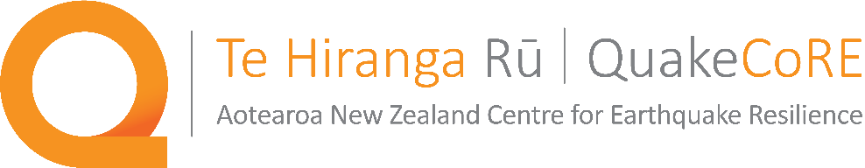

2020 Te Hiranga Rū QuakeCoRE Strategic Funding

Pandemic Support Grants

Overview [Delete this information before submission]

Te Hiranga Rū QuakeCoRE recognises that the 2020 COVID-19 pandemic has had, and continues to have an impact on everyone in Aotearoa New Zealand. The impact of the pandemic and associated government measures to manage the risk, have been seen to have a disproportionate effect on some groups. An individual’s ability to work through the lockdown period may have been impacted by childcare or whānau responsibilities, group living situations, poor internet or other personal circumstances.
Grants are available for researchers that have been disproportionately impacted by the COVID-19 pandemic to provide support for research-related costs. The aim of the grant is to allow researchers to regain momentum on their research activities, with funding to support activities such as research assistants, summer students, data collection or analysis as identified by the researcher. Pandemic Support Grants can be requested for between $5,000 and $15,000.

Please contact the Support Team (quakecore@canterbury.ac.nz) if you have any questions about this funding.

Instructions [Delete these instructions before submission]

All text in this proposal must be Calibri 11pt.
- Please complete this funding form, which will be used to create your Contract.
- Please return this form to quakecore@canterbury.ac.nz by Friday 9th October.

Applicant
Applicant’s Name:
Please select the primary research area your work is aligned with:
Choose an item.

Project Proposal
- COVID-19 Pandemic Impact
[Provide a brief summary of how research activities have been impacted by the COVID-19 pandemic. Outline the support required to help alleviate this impact.
(100-200 Words). Delete this text before submission]

- Project Budget
$
Please indicate the amount of funding you are requesting.
[Grants of $5,000 - $15,000 will be awarded under this funding].

- Budget Justification:
[Please provide details on how the funding will be used to support your research activities. Examples of uses, for which details should be provided may include, but are not limited to, one or more of the following:
  - Support for a Research Assistant; where project funding will be used to support project staff, the staff member must be named in this application document.
  - Summer Students; please provide the name(s) of the summer student where available, or details of the intended recruitment process
  - Data processing, analysis, or numerical analysis to further research

200 – 400 Words. Delete this text before submission.]

- Project Deliverables
[All project leaders will be required to complete a final project report as outlined below. Additional deliverables such as a journal article or the employment of a Research Assistant or summer student may also be included. Delete this text before submission.]

Deliverable | Due Date
Final Report  Brief report using template provided | 31 March 2021

APPLICANT CONFIRMATION
By signing this application form below, I confirm that:
- This application has been endorsed by both the applicant and employing organization
- All Te Hiranga Rū QuakeCoRE reporting requested to date has been completed
- All of the people named in this proposal have approved their involvement as written and are committed to supporting a successful project outcome

SIGNATURE:

Date:

